ACHD Final Project-Part 1

No | Name | Netid
1 | Zhaoxi Chen | Zc1134
2 | Madhumita Murai Sawant | Mms916
3 | Kush Agarwal | Ka1809
4 | Shubham Mahalank | Sm7675
5 | Xinmei Jin | Xj573
6 | Dan Wu | Dw1987
7 | Monica Reddy Tirupari | Mrt374
Team Members

Block Diagram of MIPS Architecture:
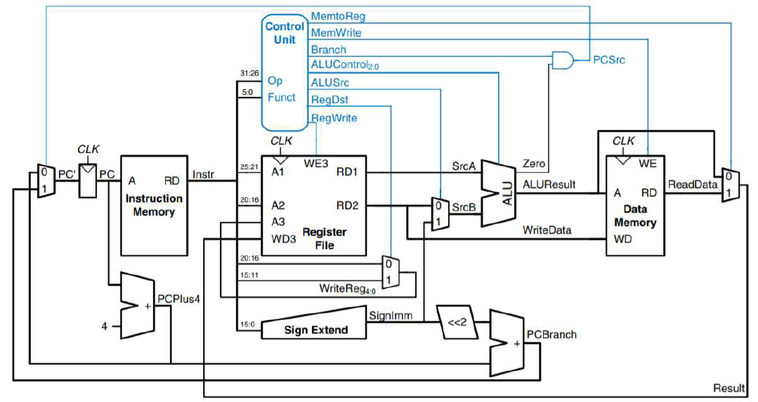
Figure 1: Complete Single Cycle MIPS Processor.
The processor implemented for the final project is a single cycle 32-bit processor. This means that it fully executes an instruction in one clock cycle only. A 32-bit processor is a processor having 32-bits long instructions. This instruction can be divided depending on the type of the instruction (R, I or J), but one constant is the opcode which is defined by the first 6 bits of the instructions starting at the Most Significant Bit (MSB). Below is a figure showing the different fields of an instruction.
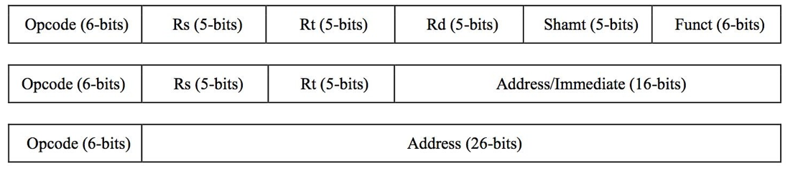
Figure 2: Instruction set for I, J and R Type of instructions.

The components that constitute our processor are the following: the Instruction Memory (IM) in which the code to execute will be placed, the Register File (RF) which will provide the values of the registers needed for an instruction and specify the register it has to write to after the execution of the instruction, the Arithmetic Logic Unit (ALU) which is responsible for the arithmetic operations such as addition and subtraction, the Decoder which breaks down the instruction to identify the value of the control signals as the instruction type for instance and finally, the Data Memory (DM) in which values can be stored

Components:

- Instruction Memory:
As described in the project requirement, the IM module is used to restore all the instruction needed to be executed in correct order. In this simulation, the instruction is set to the part 1 sample code.
00000100000000010000000000000111 --ADDI R1, R0, 7 // R1 = 7
00000100000000100000000000001000 --ADDI R2, R0, 8 // R2 = 8
00000000010000010001100000010000 --ADD R3, R1, R2 // R3 = R1 + R2 =15
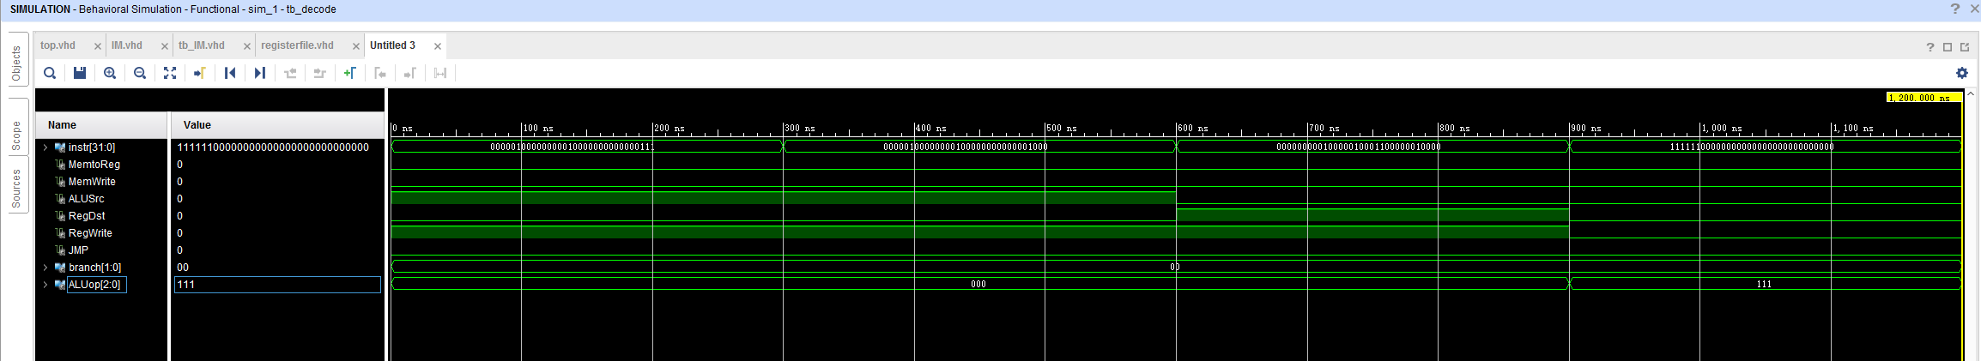
11111100000000000000000000000000 --HAL // HALT
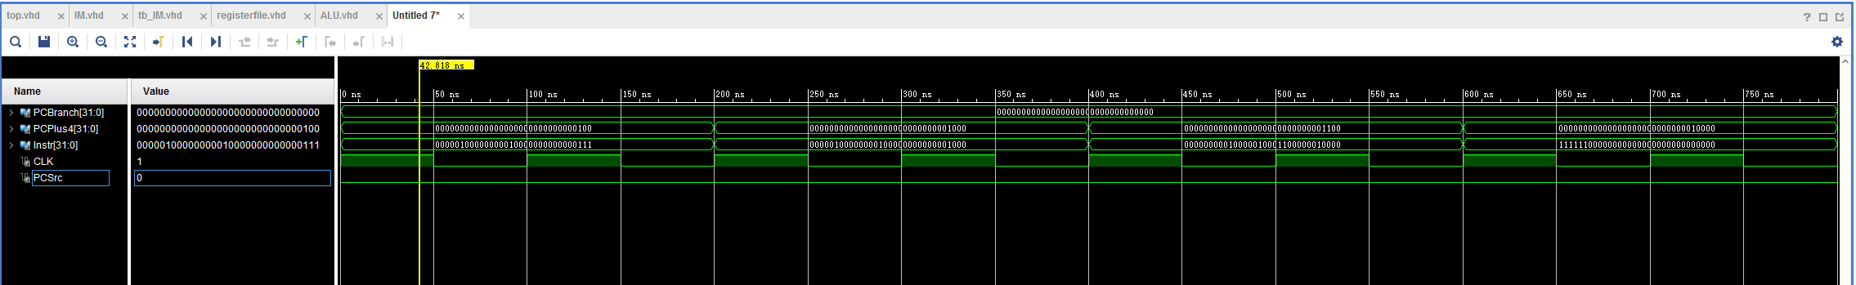
Figure 3: Functional Simulation of Instruction Memory.

- Decoder:
Decoder unit for the circuit (which is the control unit in the image)
The input of instruction is just the test code 1 from part 1 requirement
Figure 4: Functional Simulation of Decoder.
- Register file:
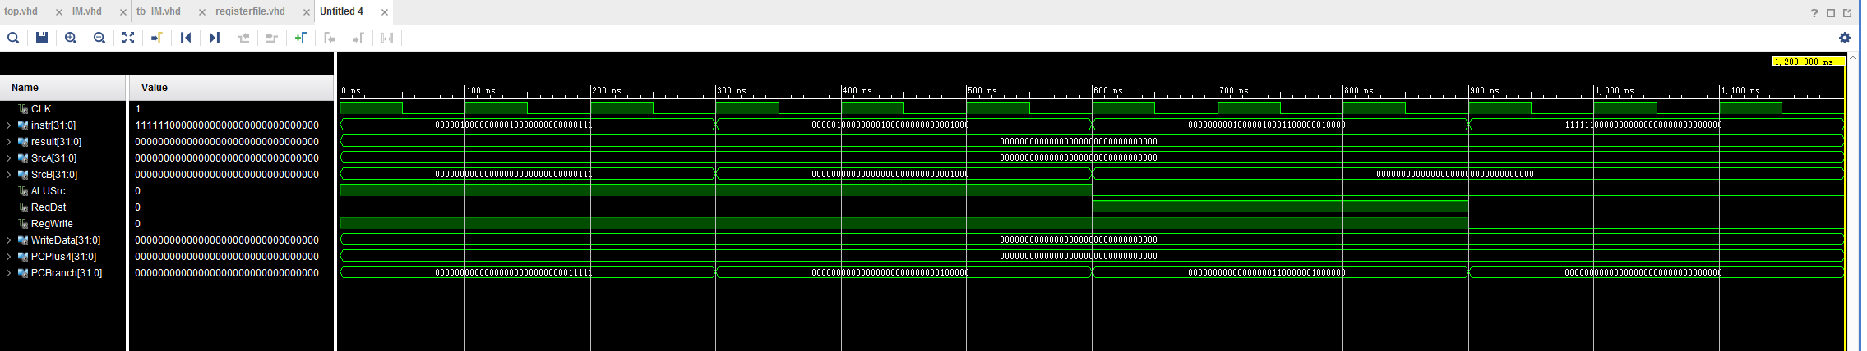
input instruction also comes from the example part 1 code which have 4 instructions, the input of ALUSrc, RegDst, RegWrite comes from the same time output of the decoder simulation up above.
Figure 5: Functional Simulation of Register File.

- ALU:
ALU is one of the necessary component in a processor. It is responsible for arithmetic, logic and immediate operations like Addition, Subtraction, AND, OR, NOR, Left Shift and Right Shift. The unit receives two inputs srcA and srcB each of 32 bit. One input is from the register file and the other input is from the register file or instruction memory directly. ALUControl is a control signal based on which the corresponding operation to be performed by ALU is selected. The output is sent as an address to Data Memory Unit.

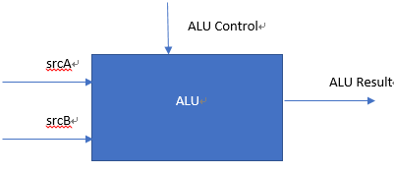

Figure 6: ALU Block Diagram

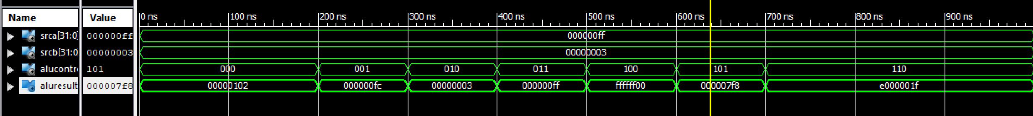
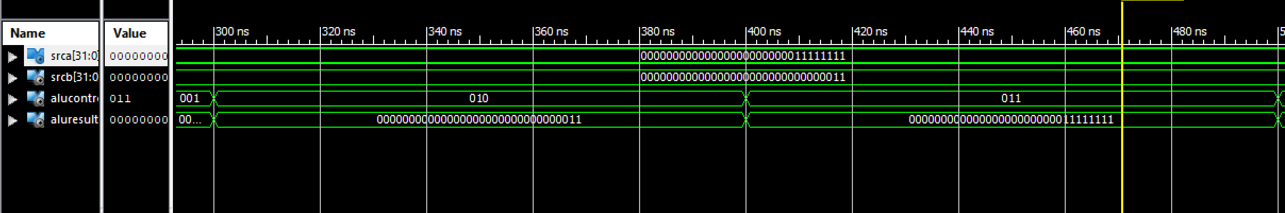
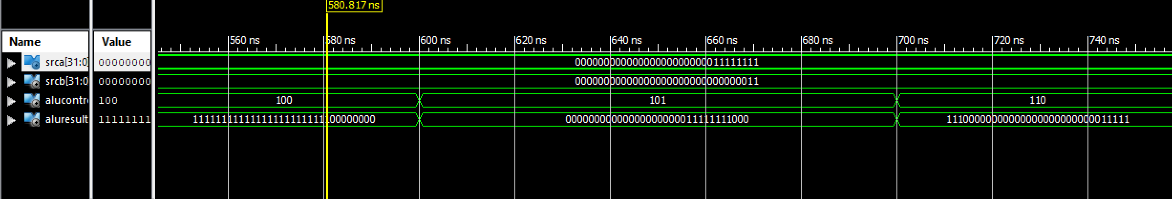
Figure 7: Functional Simulation of ALU
Operation Table:

Operand 1 (srcA) | Operand 2 (srcB) | ALU Operation  (ALUControl) | ALUResult
000000FF | 00000003 | 000 (Add) | 00000102
000000FF | 00000003 | 001 (Subtract) | 000000FC
000000FF | 00000003 | 010 (AND) | 00000003
000000FF | 00000003 | 011 (OR) | 000000FF
000000FF | 00000003 | 100 (NOR) | FFFFFF00
000000FF | 00000003 | 101 (Left Shift) | 000007F8
000000FF | 00000003 | 110 (Right Shift) | E000001F

Resource Utilization:
 | Synthesis Stage | Place and Route Stage
LUT FF Pairs Used | 322 | 306
Fully Used LUT FF Pairs | 0 | 0
Number of bonded IOBs | 99 out of 210 | 99 out of 210

- Data Memory:
The Data Memory, RAM, is an array of 64 memory locations. Each having a 32-bit data.
Some of the test case simulations are done using a test bench and some are done by simply forcing the values.
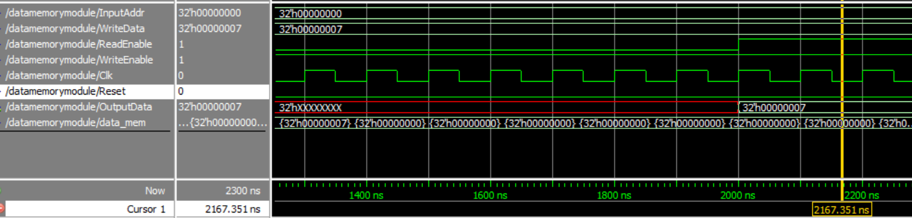
- To Write data and Read output.
Figure 7(a): Functional Simulation of Data Memory

Here I want to write data to Data Memory location 32h’0, i.e. the first location. The data to be written is 32h’07.
So, first I made the read enable ‘0’ (disabled reading) and wrote the data in the memory location that we want. Then once I ran a couple of those cycles, I made read enable ‘1’ to read the output data. The output data is the data shown of the memory location where changes are made.

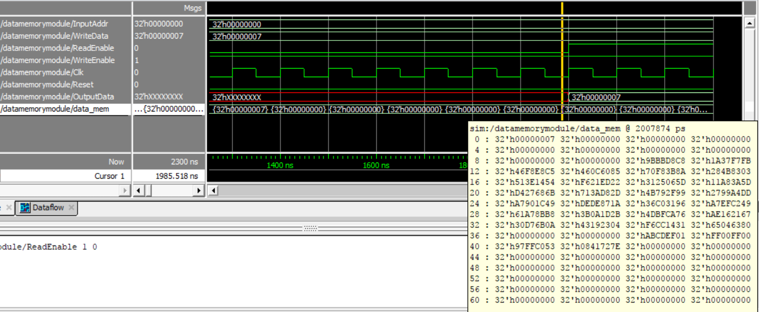
Figure 7(b): Functional Simulation of Data Memory

In the image above, you can see that the 0th memory location has the new data, 32h’00000007 written in it (encircled in red).
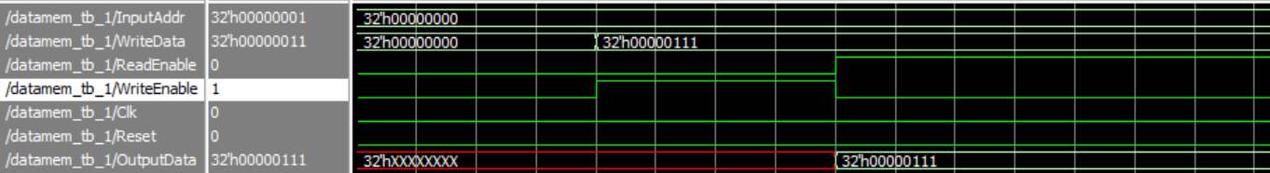
- To Read Data:
Figure 7(c): Functional Simulation of Data Memory

Summary of Resource Utilization in Data Memory Simulation:

 | Synthesis Stage | Place and Route Stage
Slice LUTs | 780 | 746
LUT FF pairs used | 2794 | 2215
LUT FF pairs with unused FFs | 714 | 135
LUT FF pairs with unused LUTs | 2014 | 1469
Fully used LUT-FF pairs | 66 | 611
Number of bonded IOBs | 74 | 74
Reason for the Difference | This is an estimate of the design requirements and not the actual number, so the LUTs used are more. The information here is quite limited and inaccurate. | Here, actual hardware realization is performed. This is done by modelling the circuit and then the requirements report is generated. Thus, the LUT values go down. The information given here is detailed and accurate.

Combined Circuit:

The first part of the verification was to make sure that every component was doing what it was supposed to do. To this end, every component was tested individually. Above are the screenshots for the ALU and the decoder. After that, the complete processor was put together and the following programs were tested to check that every instruction is working properly.

Sample program 1:

ADDI R1, R0, 7 ADDI R2, R0, 8 ADD R3, R1, R2 HAL
The above assembly code should result in the following output. R1 = 7;
R2 = 8;
R3 = 15;

When executing the above code in our processor we get the following output

As we can see,
R1 = 7;
R2 = 8;
R3 = 15;
Hence Correct Output Received.

Sample Program 2.

ADDI R1, R0, 2 ADDI R3, R0, 10 ADDI R4, R0, 14 ADDI R5, R0, 2 SW R4, 2(R3)
SW R3, 1(R3) SUB R4, R4, R3 SUBI R4, R0, 1 AND R4, R2, R3 ANDI R4, R2, 10 OR R4, R2, R3
LW R2, 1(R3)
ORI R4, R2, 10 NOR R4, R2, R3 SHL R4, R2, 10 SHR R4, R2, 10 BEQ R5, R0, -2 BLT R5, R4, -2 BNE R5, R4, 0 JMP 20
HAL

The above assembly code results,
R1 = 2
R2 = A
R3 = A
R4 = 0
R5 = 2

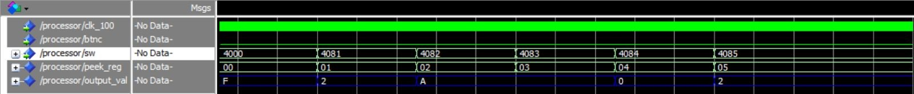
When executing the above code in our processor we get the following output

As we can see from the above screenshot, the following are the output.
github link: https://github.com/Nie13/6463processor

